**EXPERIMENT 1**

**Title:** Installation of GIMP and Blender

**Objective:** To install animation tools GIMP and blender on system.

**Theory:**

**GIMP** stands for GNU Image Manipulation Program. It is a cross-platform image editor available for GNU/Linux, OS X, Windows and more operating systems. It is [free software](https://www.gnu.org/philosophy/free-sw.html), and its [source code](https://git.gnome.org/browse/gimp) can be changed and [distribute](https://www.gnu.org/licenses/quick-guide-gplv3.en.html)d. Whether one is a graphic designer, photographer, illustrator, or scientist, GIMP provides with sophisticated tools to get the job done. We can further enhance our productivity with this platform. GIMP is a high-quality framework for scripted image manipulation, with multi-language support such as C, C++, Perl, Python, Scheme and more! It can be downloaded directly from www.gimp.org

**Blender** is the free and open source 3D creation suite. It supports the entirety of the 3D pipeline—modelling, rigging, animation, simulation, rendering, compositing and motion tracking, video editing and 2D animation pipeline. The latest version can be found on www.blender.org

**Procedure:**

**(A**) How to install GIMP?

**Step 1:** Download the GIMP installer from gimp.org/downloads for free.

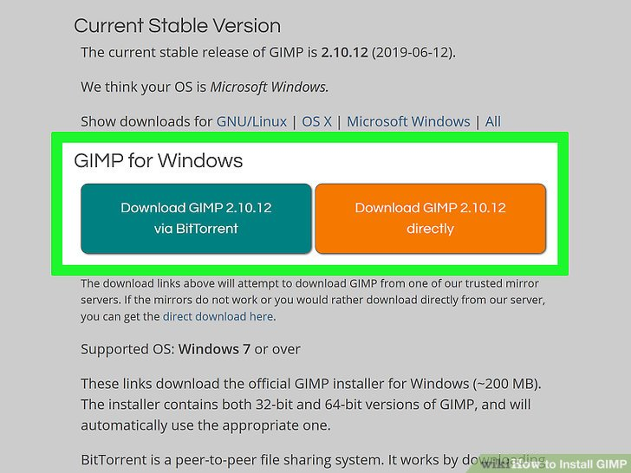

**Step 2:** Run the GIMP installer from the location you saved it to, generally your Downloads/My Downloads folder.

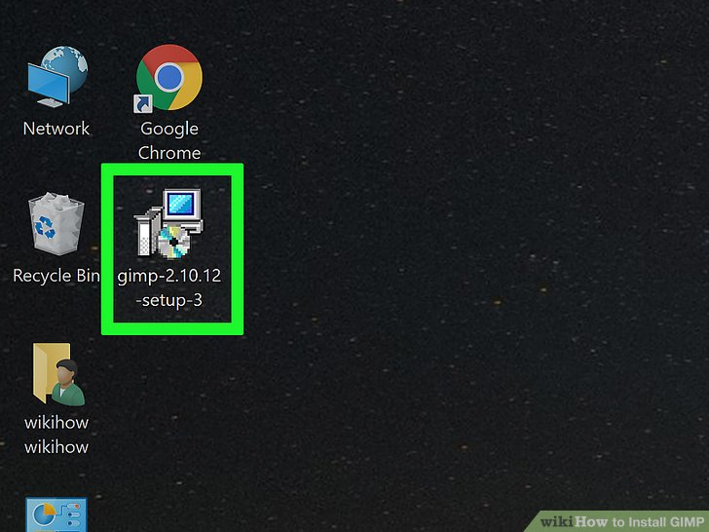

**Step 3:** Follow the prompts to install GIMP. Most users can leave the settings at the defaults.

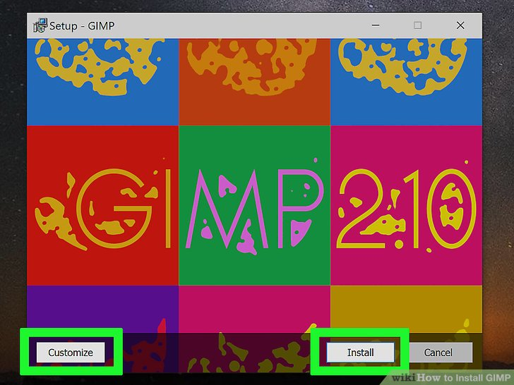

**Step 4:** Finish the installation. After selecting the file formats, GIMP will install. This may take a few minutes.

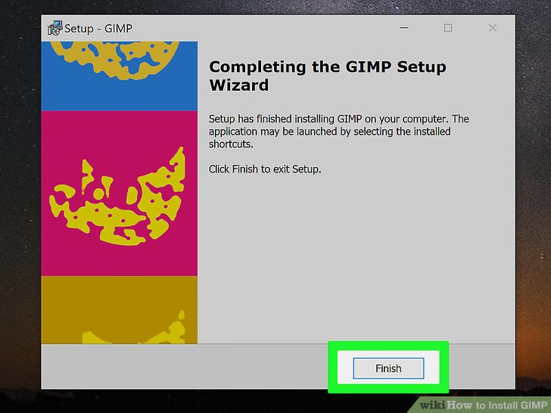

**Step 5:** Start using GIMP. Once GIMP has finished installing, you can start using it.

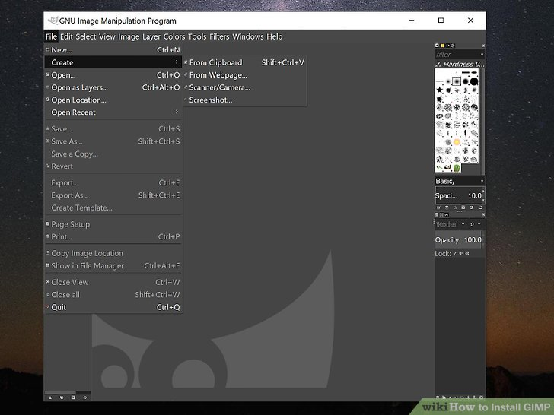

**(B)** How to install Blender?

**Step 1:** Visit the Blender website i.e. blender.org.

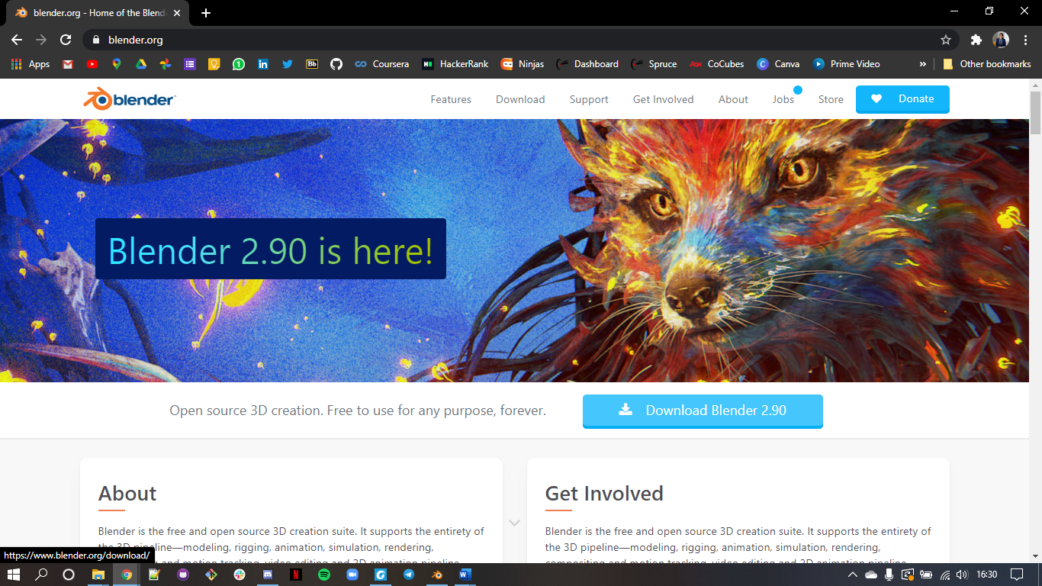

**Step 2:** Click on the link to access the Download page. Also, select the operating system to install the program.

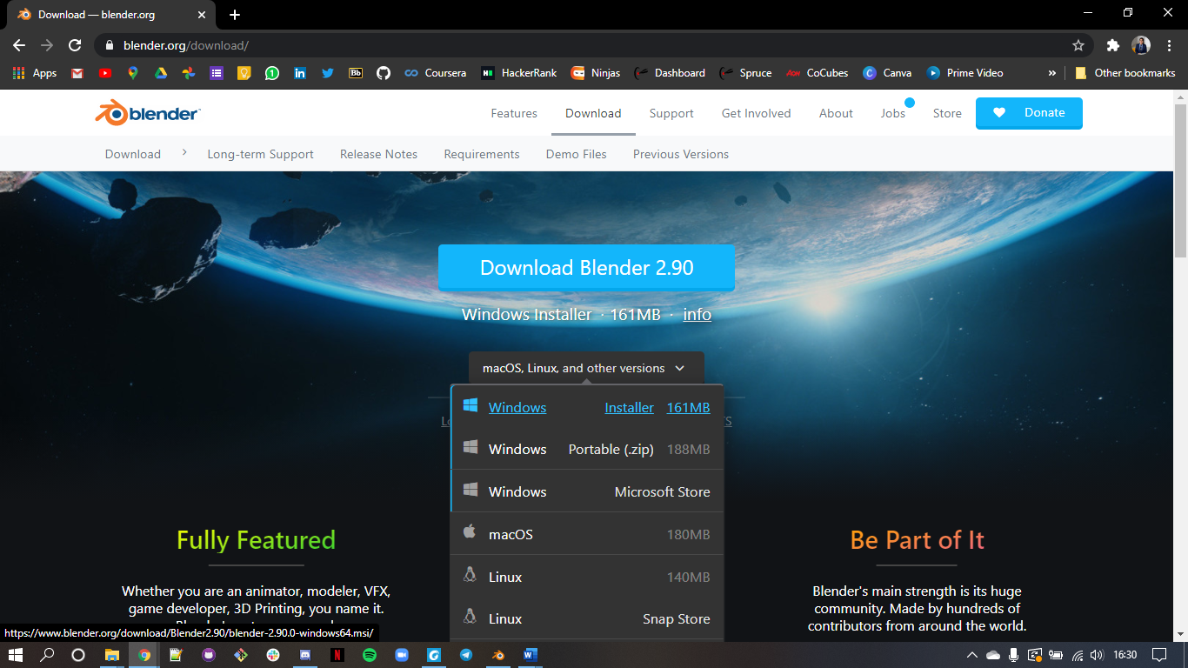

**Step 3:** Now, run the downloaded Installer which will probably be available in the download folder.



**Step 4:** Now, click on the Next Button to initiate the installation process.



**Step 5:** Click on the Next Button, when asked to move ahead in the process.

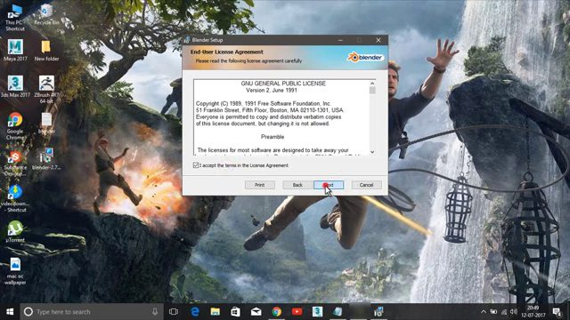

**Step 6:** In this step, the user can change the default location of the program. Click Install to Move ahead.

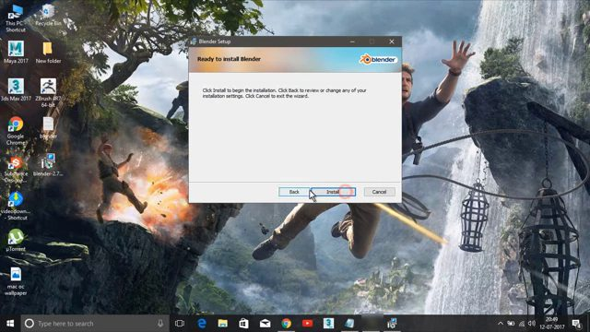

**Step 7:** Wait for the Program to Install Blender.

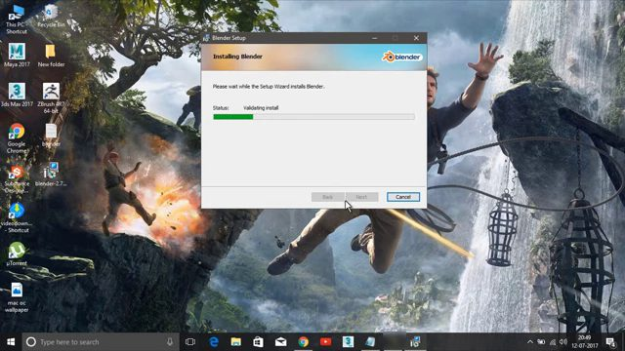

**Step 8:** Click on Finish and complete the Installation Blender process.

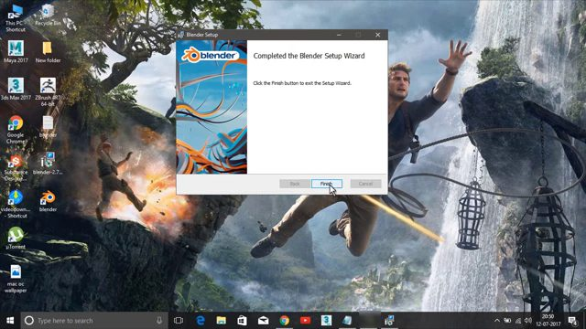

**Step 9:** After installing the program, the Blender window will look like this. The interface of Blender is the same across all the operating systems.

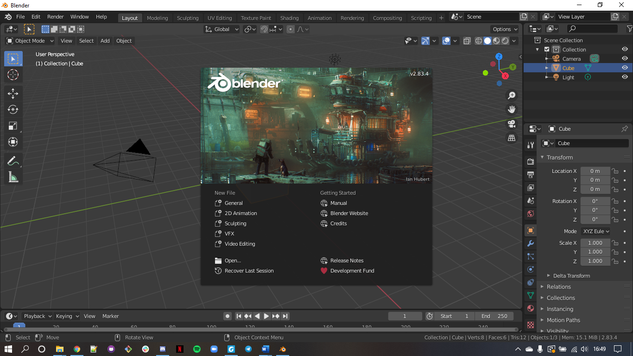

**Conclusion:** Successfully installed GIMP and Blender.